SURVIVAL OR EXTINCTION

by
KEVIN MUGUR GALALAE

PART TWELVE
PEACE WITHOUT POISON
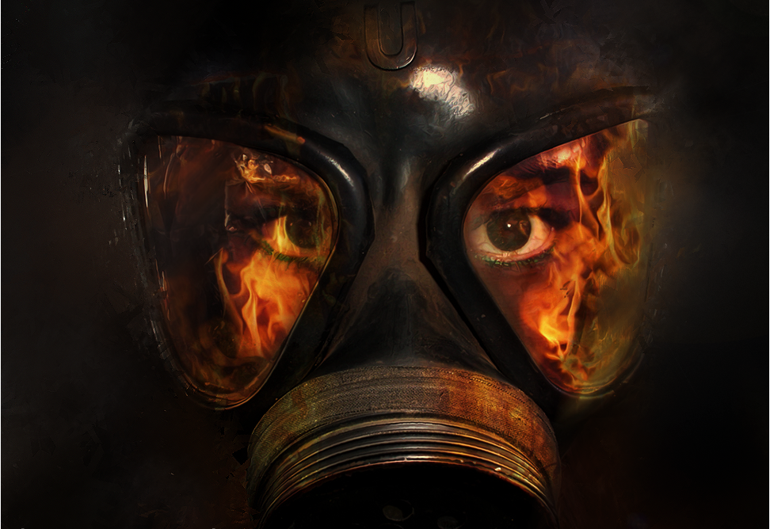

(PART ONE: LIFE OR DEATH; PART TWO: FOLLOW THE MONEY; PART THREE: NEED NOT GREED; PART FOUR: TAMING THE WOLVES; PART FIVE: DISCARD ME NOT; PART SIX: HEAD AND HAND; PART SEVEN: POWER OF MONEY; PART EIGHT: BURDEN OF RESPONSIBILITY; PART NINE: CONCEAL AND DECEIVE; PART TEN: CRISIS OF LEADERSHIP; PART ELEVEN: COUNTRIES ARE PRISONS)

From the horrors and convulsions of wars past, humankind has advanced step by bloody step, from one peace settlement to another, towards the concept of collective security. Each major peace accord in Europe and beyond has sought to regulate international affairs better than previous efforts in the hope of finally securing peace and stability into the future.
At the Peace of Westphalia in 1648 national sovereignty triumphed over imperial ambitions and the first semblance of an international order was established. At the Peace of Utrecht in 1713 balance of power was recognized as crucial to international relations if in the years to come no state was to take advantage of its military superiority. At the Vienna Peace Congress in 1815 long-term peace was secured by resizing the main European powers to achieve the balance of power envisioned a century earlier but delayed and denied by Napoleon’s aggression. In Vienna, for the first time in history, national representatives came together to formulate a peace treaty for an entire continent and create the international framework necessary to do so, preventing another Europe-wide war for a century by giving diplomacy the opportunity to settle future disputes through negotiation before they resulted in war.
The Paris Peace Conference, which concluded World War I in 1919, begot the League of Nations, the first international organization created to maintain world peace. Its covenant – to prevent war through collective security and disarmament and to settle international disputes through negotiation and arbitration – built on the lessons learned from past experiences. But the League of Nations lacked the political will necessary to employ the war prevention instruments it devised, and could neither enforce its resolutions and sanctions nor project military force without an army, which is why it failed in its task after only 20 years of existence, when instead of acting against Hitler it succumbed to appeasement. The shortcomings of the League of Nations are ultimately rooted in the fact that it was composed of sovereign states willing to negotiate conflict peacefully but unwilling to give up national jurisdiction for the sake of international security, which is why the US Senate, incidentally, did not ratify the agreement and America stayed out of the League, despite President Wilson being its main architect.
It took another global war, World War II, and the threat of assured mutual destruction by nuclear weapons, to compel the world’s sovereign states to create a neutral international organization in 1945, the United Nations Organization, and abdicate to it national jurisdiction over areas crucial to maintaining peace between nations, areas that were deemed international security prerogatives and were entrusted solely to the authority of the UN.
To bypass the democratic process and national sovereignty, the founding nations of the United Nations agreed, upon becoming UN Member States, to gradually give up command and control over the two international security prerogatives that were identified to be the ultimate causes of all wars: population and resources. Nuclear deterrence compelled even the most powerful nations to toe the UN line.
To prevent war, the UN, unlike the League of Nations, understood that it must take preemptive action to ensure that the pressures which lead to war never arise or if they do arise they do not become so acute as to make war inevitable. The architects of the UN reasoned that the only way to prevent war is to preempt it, in other words to eliminate the conditions that force nations to go to war, and that the best way to preempt war is by finding a substitute to it, for that is the only way to rob war of the fuel and oxygen it needs to burn; the fuel being overpopulation, hence the Global Depopulation Policy, and the oxygen resources, hence the Free Market Economy.
If a country keeps its population in check until it is stable and thus neither grows nor decreases it can properly manage its resources and meet the needs of its citizens. Thus the rationale of the Global Depopulation Policy is for each country to reach a balance between the number of its people and the available resources – so the people do not outgrow the existing resources – and to maintain that balance in perpetuity.
In recognition of the fact that natural resources are unevenly distributed on the planet and that industrialization necessitates access to vital resources that may or may not be available at home in sufficient quantities, the UN, guided and assisted by the US, created the international environment and institutional infrastructure necessary to give every nation on earth the opportunity to buy what it needs on the free market. Thus the rationale of the Free Market is to enable every nation on earth to freely trade with other nations the resources it has in abundance for resources it lacks – so that all nations have the same opportunity to industrialize and prosper – rather than be forced by resource scarcity to wage war.
The UN was also endowed with peacekeeping forces to ensure that no petty tyrants or aggressor nations with territorial ambitions or predatory mentalities force peaceful nations to defend against intrusion or encroachment. And that is how peace and stability have been maintained in the world for the past 69 years and how the international community has succeeded in preventing another global war though not necessarily ensuring universal prosperity, which is why now the world’s security and stability are threatened by moral, economic and environmental factors which unless urgently addressed will lead us to perdition.
What the struggle for peace throughout our history teaches us, is that war breaks out because nations are unable to respond to the fast evolving conditions within society or the quickly deteriorating environment between societies, either because they lack the tools necessary to respond or the wisdom to identify what ails society before it is too late. In other words, we are not smart enough to stay one step ahead of trouble.
The collective pain of conventional wars past, when millions of soldiers died in trenches, has been replaced by the individual pain of the covert war waged on the fertility and longevity of civilians so that we now suffer in quiet desperation, live disabled lives and die alone in hospital wards and bedrooms of diseases caused by the chemical, biological and bacteriological weapons directed at us and at our innocent and vulnerable children without our knowledge or consent, but with the full knowledge and tacit consent of our elected governments and religious leaders.
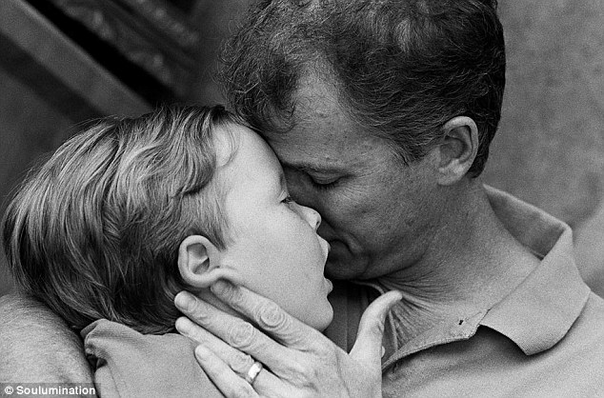
A father’s love: Greg holds his son, Blake, who died in 2006 at just five years old (photo by Soulumination)
And the material hardship caused by the wanton destruction of past wars has been replaced by the economic hardship engineered to subvert the family so that fewer families thrive and in this fashion the world achieves its demographic objectives.
What started as a plan for peace and with the best intentions has decayed into a silent war with diabolical objectives. This is not the noble outcome envisioned either by the idealism of Wilson’s Fourteen Points in 1919 or by Roosevelt’s Atlantic Charter of 1941, which constitute the philosophical underpinnings of the United Nations Charter, signed in 1945, and of the Universal Declaration of Human Rights, adopted in 1948.
At the Dumbarton Oaks Conference in the US in 1944, where the shape and function of the United Nations was negotiated among international leaders, the objectives of the proposed organization were laid out clearly by the American delegation and they are noble indeed:
- To maintain international peace and security; and to that end to take effective collective measures for the prevention and removal of threats to the peace and the suppression of acts of aggression or other breaches of the peace, and to bring about by peaceful means adjustment or settlement of international disputes which may lead to a breach of the peace;

- To develop friendly relations among nations and to take other appropriate measures to strengthen universal peace;

- To achieve international co-operation in the solution of international economic, social and other humanitarian problems; and

- To afford a center for harmonizing the actions of nations in the achievement of these common ends.

As war between nations became impossible, structural violence within nations increased accordingly to make up for the depredations of war where social, political, ethnic and especially economic problems found their ultimate resolution before the world decided to maintain peace between nations at all costs. And that is why conventional war between nations has been replaced by covert structural violence within nations, violence directed and calibrated by the state against its own civilians to preempt the formation of pressure points before they become threats to peace.
As the world’s social, economic, cultural, ethnic, religious and material problems grow along with the global population so does the structural violence nation states perpetrate on their own citizens, with the assistance of the United Nations, to keep the world at peace.
It is up to us to ensure that peace means more than just the absence of war. It is up to us to ensure that we have peace without poison. Our governments are clearly incapable of true peace, of peace without poison, since true peace is impossible without the contribution of each and every person on the planet. The international community of nation states has been able to give us peace with poison by accepting that the treatment of citizens within borders is a matter of legitimate international concern. But only a global community of citizens who understand that their own behavior within borders is a matter of legitimate international concern can give us true peace, peace without poison, as this will shift the onus of responsibility from the state to the individual, as well as the benefits, and will depoliticize the process of collective security.
The problem we now face as citizens under attack by the very governments we have elected to protect us is how do we respond to the degeneration of a noble idea to secure peace between nations to a diabolical plan to commit genocide within nations? Can we identify and address the conditions that have led to this degeneration? And can we force a change of course without triggering a global war? Can we, in other words, have peace without poison? Are we capable of peace without poison? And if so, how?
These are questions for which the past can provide no answers, for the problems are unprecedented. Yet these are the questions that ought to preoccupy our leaders and not the meaningless bickering over self-serving personal or even national interests. But no such soul-searching and farsighted leadership is to be found within the national or international establishments of power, where politicians, bureaucrats, technocrats, generals, cardinals, judges, doctors and scientists are marching blindly towards humanity’s destruction instead of reaching out to humanity for humanity’s salvation. For only by empowering the person can the world find peace.
Damn them all to hell, this useless lot of cowards and parasites who have turned the world into a gas chamber and have scheduled us and our children for annihilation! Damn them all to hell!
God will not forgive that they have chosen to dedicate their lives to the destruction of life.
And damn all those pontificating fools to hell who would rather hang on to their stale religious beliefs than admit the obvious reality that unless we assume responsibility over the population problem in our own bedrooms and share the world’s bounty with those who call God by another name there will be no tomorrow! Damn them all to hell!
God most certainly does not want any of them to foul his heaven with their putrid dogmas.
God wants neither friends of nature who are enemies of man, nor enemies of nature who are friends of man.
What God wants is to conduct our affairs without destroying his creation. He wants us to be friendly to each other and friendly to nature. He wants us to restore his earthly paradise so that all life on earth can continue to live and evolve. He wants security for all his creatures. He wants us to understand that our collective security depends on the security of the planet, on the security of all life on earth. He wants Planetary Security. And Planetary Security can only come from harmony. And harmony can only come from people, not from nations.
Planetary Security depends on globally coordinated action: political, economic, environmental and social. But more than anything it depends on each and every one of us expanding our horizons to see the world as a whole and not just our neighborhoods and countries, not just our interests and dreams. Once we look at the world as a whole it becomes painfully obvious that paradise is full. It has been filled and fouled by human recklessness. Our dreams have become the earth’s nightmares. To clean up the earth we must clean up our act and to clean up our act we must confront the problems we have created full on and without hesitation…and we must confront them as individuals not as citizens of nations.
The overarching problems that we must address as individuals if we are to accomplish Planetary Security are as follows:
- Developing nations cannot catch up with developed nations because they started their industrialization much later and are consequently at disadvantage, which means that the free market economy cannot provide all nations with the capital, knowhow and resources they need to satisfy the material needs of their people and even less so their economic ambitions. Only wide-ranging intervention in the free market can shift sufficient capital, knowhow and resources from the developed to the developing world to bring the latter up to the same level of development as the former.

- Poor nations are outbid by rich nations on the free market and therefore cannot buy the resources they need to industrialize and reach the West’s standard of living. Equal access to resources presupposes equal financial means to buy them and no such equality of income exists in the world. Only a complete transformation of the monetary system to a global digital currency can facilitate equality of income and equality of access.

- Vital resources necessary for industrialization are becoming increasingly scarce so competition for them rises along with population growth which means there are not enough resources on earth for the developing world to reach the developed world’s standard of living or to even maintain their existing standard. Only a drastic reduction of the global population can bring resources and population back into balance so that a uniformly high standard of living can be achieved across the world.

- Digitization and mechanization displace increasingly more people from the economy at a time when increasingly more people are looking for jobs due to still growing populations, destabilizing the entire capitalist socio-economic model which is as a result on the verge of collapse. Only a radically different distribution of wealth and labor can restore economic and therefore political stability in the world.

- Environmental tipping point has been reached due to unbearable pressures placed on the ecosystem by virtue of our needs and numbers. Only a vastly reduced global population accompanied by the universal and speedy adoption of renewable energy sources can ensure that we bring our civilization within the regenerative capacity of Mother Earth. To accomplish such a population reduction equitably and justly so that no genetic line is shut down and we can all perpetuate our lineages the world needs an organ with global executive control over depopulation and the power to impose its will on even the most reluctant nations and people. That is the only way the covert poisoning can stop and the overt shouldering of responsibilities can start.

- As the populations of nation states still grow and the buffer zones that abundant land provided us with in the past have disappeared, poverty and lack of opportunity have triggered mass migration and are forcing the cohabitation of ethnic groups that have never before lived together. Only the immediate elimination of national frontiers and global citizenship can allow us to defuse the world’s pressure points and survive the necessary transition from a world of nations to a planetary civilization. And only a no tolerance policy towards intolerance can keep people’s racial, cultural and religious prejudices in check until such time as we are comfortable living with one another and a state of equilibrium is reached within the diversity of a global civilization.
The gradual steps taken by the international community of nations, impeded by structural and political obstacles, have not kept up with the pace at which the world’s material and environmental realities have evolved. While history is racing we have been only jogging and now we have to fly to catch up.
To fly to where we need to be, if we are to have peace without poison and Planetary Security, the new international infrastructure must be readjusted from the top down, by reforming the United Nations to transform it from an organization of nation states to an organization of individuals.
OM Principle ten spells out how we can do this.
PRINCIPLE 10
INTERNATIONAL ORGANIZATIONS UNDER DEMOCRATIC CONTROL

The United Nations will be reformed by dissolving the Security Council and by ensuring that each member of the General Assembly is voted into office by general elections at the regional level and that he/she has no affiliation whatsoever to the ruling party and no contact with the national authorities for as long as he/she serves in office. The role of the people-elected UN General Assembly will be that of a global government limited to working towards a one nation world by coordinating a plan for global unity that adheres strictly to the highest standards of international law, but that allows enclaves of stubborn regional and cultural differences to live by their norms and values as long as they are limited to clearly delineated geographic areas and do not impose their rules on global citizens who pass through or choose to or have to reside in their areas of control.

The reformed United Nations will in effect cease to be an organization of nation states and will become an organization of independent individuals. It should therefore be renamed the United Peoples Organization.
The stated roles of the United Nations are to maintain international peace and security, promote human rights, foster social and economic development, protect the environment, and provide humanitarian aid in cases of famine, natural disaster, and armed conflict. Its unstated roles, which are international security prerogatives, are to control population growth and facilitate access to resources.
The fundamental role of the United Nations Organization, which is to prevent aggression by one nation against another, will have ceased to be relevant in a world where the nation state has given up executive control over security and resources to the United Peoples Organization, whose fundamental role will be to be prevent human aggression against the planet and to retire all forms of structural violence that nations states perpetrate against individuals.
The new international infrastructure will have therefore broadened and deepened its scope to include three new or redefined objectives that are necessary to accomplish Planetary Security:
- Reduce the global population to a sustainable level
- Afford every human being on the planet equal access to resources and the basics of life
- Bring human civilization in harmony with Mother Earth
To accomplish these objectives, the new international structure must have at the top an executive body that is democratically elected but endowed with the authority to pursue the Planetary Security prerogatives of depopulation, resource sharing, and ecological harmony undemocratically if need be yet with full transparency and with utmost respect for human dignity. In chapter eight I described the possible makeup of such a body and gave it the tentative name “The Council of 12”, which denotes the number of elected members it will have. This structure will free the world from the tyranny of the global bureaucracies that perpetrate crimes against humanity in the form of structural violence on an unprecedented scale and without any accountability.
The manpower and capacity of the United Nations Economic and Social Council (ECOSOC), which is currently one of the UN’s five principal organs and is responsible for coordinating the work of fourteen specialized agencies, as well as the manpower and capacity of the Secretariat, which is currently responsible for the administration of the UN, must be transferred and made ancillary to the newly created executive body to serve its needs in full transparency. The position of the Secretary-General, who currently sits atop the Secretariat, can be transferred to the Council of 12, renamed World President and given the power to cast a vote only to resolve a deadlock if the Council of 12 cannot reach majority.
The new international structure will thus have only three principal organs, the Council of 12, the General Assembly, and the International Court of Justice, as opposed to the current structure which has five principal organs – Security Council, General Assembly, ECOSOC, Secretariat, and International Court of Justice.
This new international structure will give primacy to capable individuals authorized to act in the best interests of humanity and not to nation states that are limited to national interests. This new structure will also set the individual above the system and in control of the system so that structural violence is halted once and for all and peace without poison becomes a reality without triggering a conventional or worse a nuclear war.
This is what the world needs. This is the only way forward. And this is the only way to return the world to sanity so that we all have a future and a say in it as well as responsibilities that are global.
The choice is simple: either we proceed with the secret methods and structures employed by nations and the international community and continue to turn the world into a toxic dump and kill each other with nuclear, chemical and biological weapons in secret or we transform our system so that we as individuals can acquire the knowledge, the power and the goodwill necessary to solve the world’s social, economic, political and environmental problems rationally and compassionately.
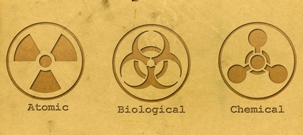
It is no coincidence that the current power structure, beholden to rigid bureaucracies and subverted by petty national interests, cannot lead us into the future and the world around us is collapsing.
It is no coincidence that this new understanding and the courage to utter it comes neither from a nation nor from the international community but from an individual.
For the system is dead and man resurrected.

